**Example 3.1.1**:

Let *A* = {a, b, c, d}

and *B* = {x, y, z}

Define *F*: *A* → *B* as follows:

*F(*a*)* = *x,* *F(*b*)* = *y*, *F(*c*)* = *z* and *F(*d*)* = *z*

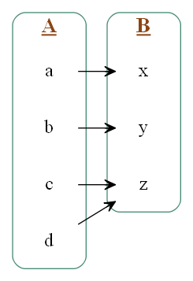

**Figure. 3.1 di-graph for function *F***

* 1. Properties of Functions

In this section we discuss two important properties that functions may satisfy: the property of being *one-to-one* and the property of being *onto*. Functions that satisfy both properties are called *one-to-one correspondences* or *one-to-one onto functions.* When a function is a one-to-one correspondence, the elements of its domain and co-domain match up perfectly.

* + 1. One-to-One Functions

The term [one-to-one](http://www.yourdictionary.com/one-to-one) relationships refers to relationships of two items in which one can only belong with the other. They are a pair. These relationships can be referred to in a mathematical sense as well, in which there are equal numbers of items. For example one employee belongs to one organization, one person has one passport, a car model is made by one company etc.

For a one-to-one function, each element of the range is the image of at most one element of the domain.

Definition

Let *F* be a function from a set *X* to a set *Y*. *F* is one-to-one (or injective) if, and only if, for all elements *x*1 and *x*2 in *X*,

if *F(x*1*)* = *F(x*2*),* then *x*1 = *x*2

**Example 3.2.1:**

Let *A* = {1, 2, 3} and *B* = {a, b, c, d}

Define *F*: *A* → *B* as follows: *F(*1*)* = *c,* *F(*2*)* = *a*, and *F(*3*)* = *d*

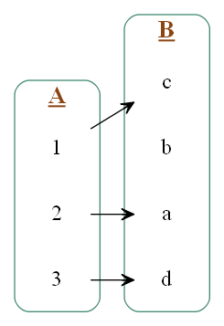

**Figure. 3.2 one-to-one function**

* + 1. Onto Functions

For onto function everyelement of a function’s co-domain may be the image of some element of its domain. When a function is onto, its range is equal to its co-domain.

Definition

Let *F* be a function from a set *X* to a set *Y*. *F* is **onto** (or **surjective**) if, and only if, given any element *y* in *Y*, it is possible to find an element *x* in *X* with the property that *y* = *F(x)*.

Symbolically:

*F*: *X* → *Y* is onto ⇔ ∀*y* ∈ *Y,* ∃*x* ∈ *X* such that *F(x)* = *y.*

**Example 3.2.2:**

Let *A* = {1*,* 2*,* 3, 4}

and *B* = {*a, b, c*}

Define *F*: *A* → *B* as follows: *F(*1*)* = *c*, *F(*2*)* = *a*, *F(*3*)* = *c*, *F(*4*)* = *b*.

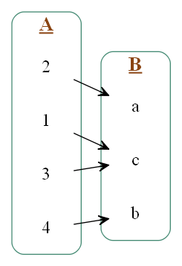

**Figure. 3.3 Onto function**

Output:

Properties of function

**Fig. 5.2 Block diagram of System for function**